PROJECT REPORT

1. INTRODUCTION

1.1 Overview

My project is about INDIAN AGRICULTURE CROP PRODUCTION. In this project, we make a sheets on tableau about agriculture land in india, crop cultivation, season based cultivation and etc,.

1.2 Purpose

This project is useful for understanding about status of agriculture in all states of India.

We can achieve the good yield in Indian agriculture through this project.

2. PROBLEM DEFINITION & DESIGN THINKING

2.1 Empathy map

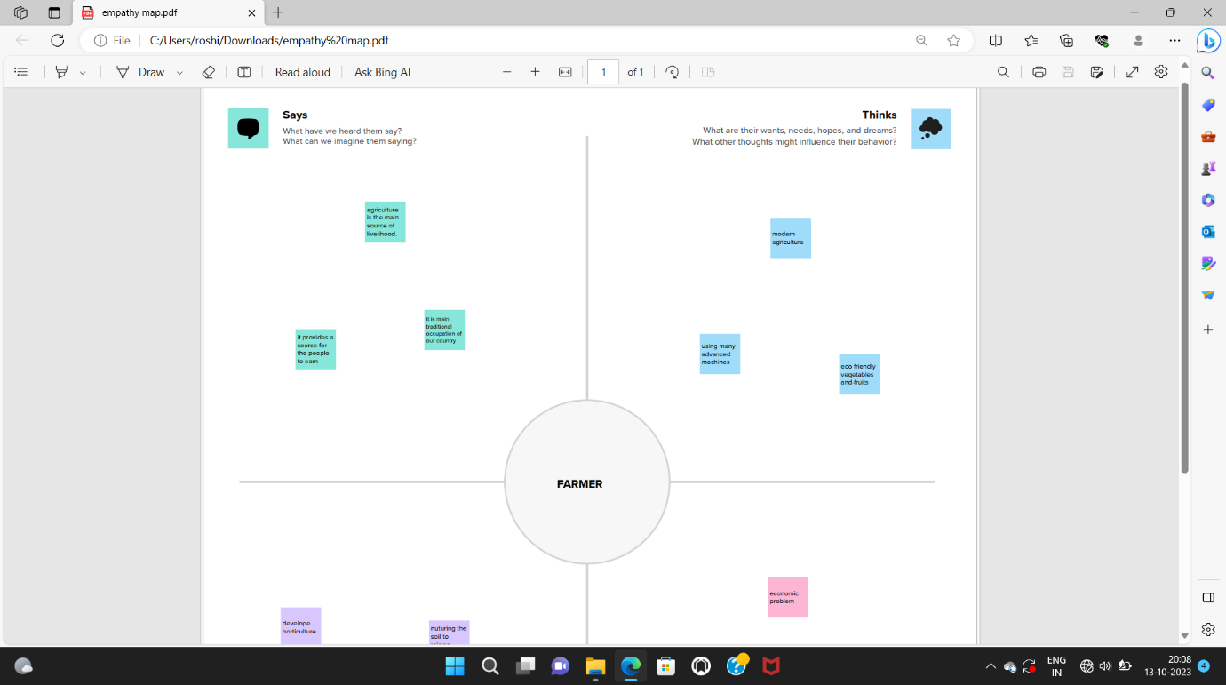

2.2 Ideation &Brainstroming Map

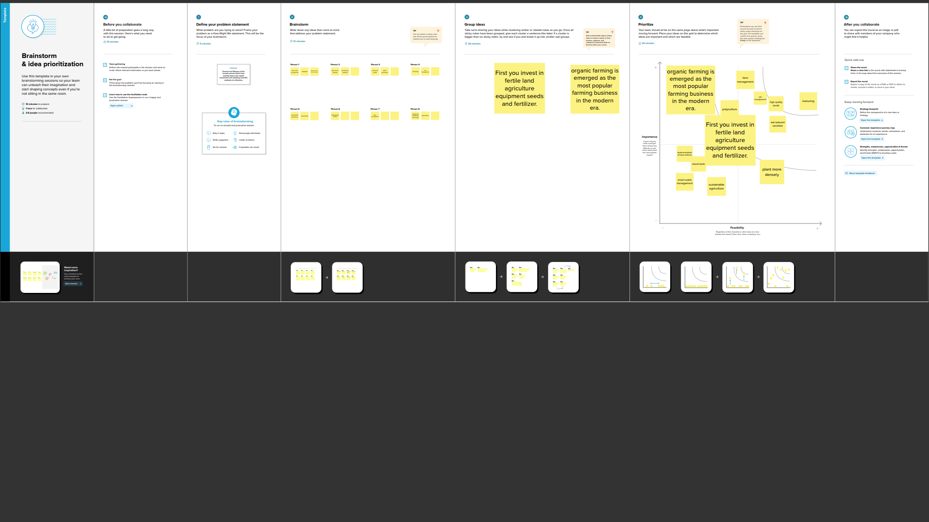

3. Results

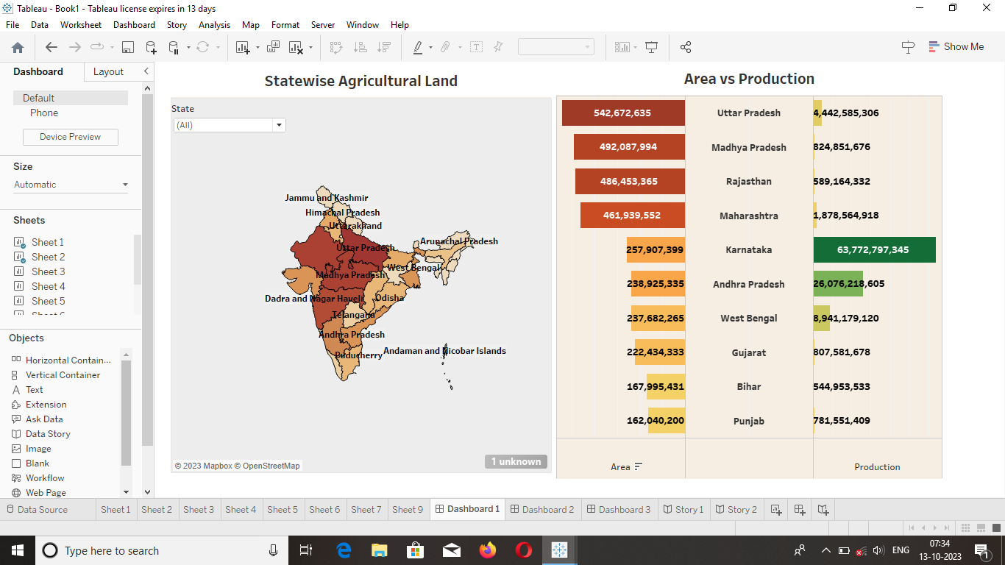

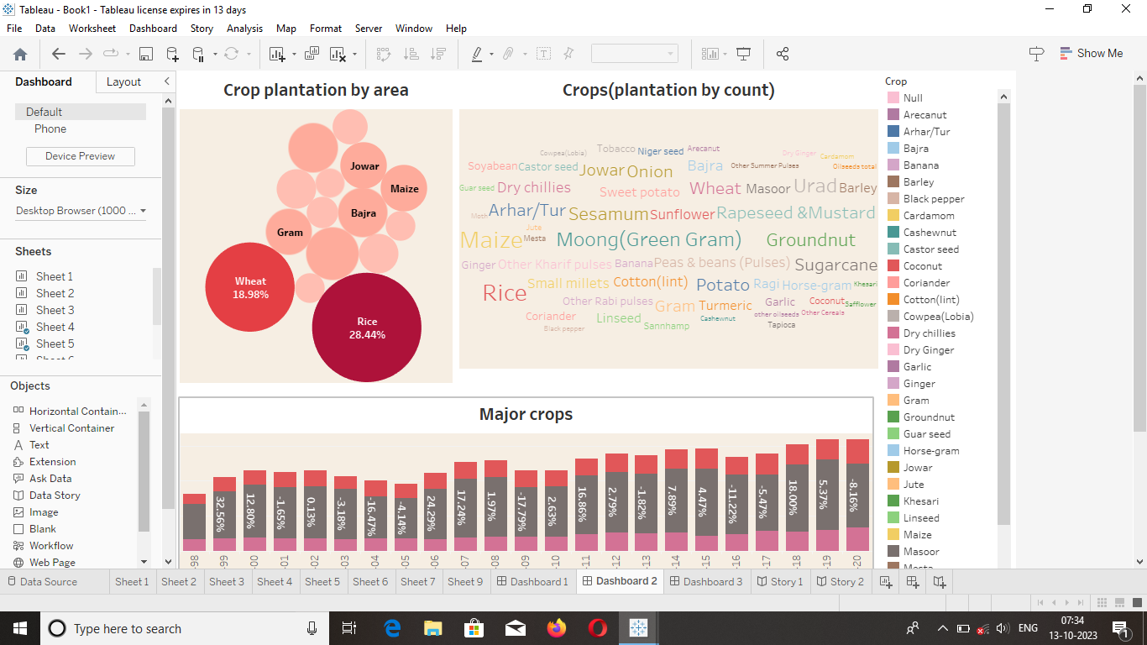

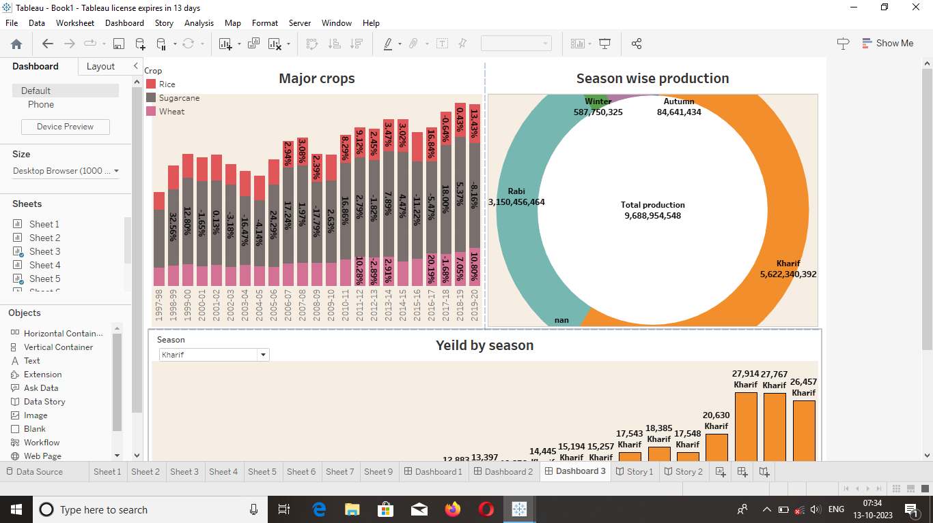

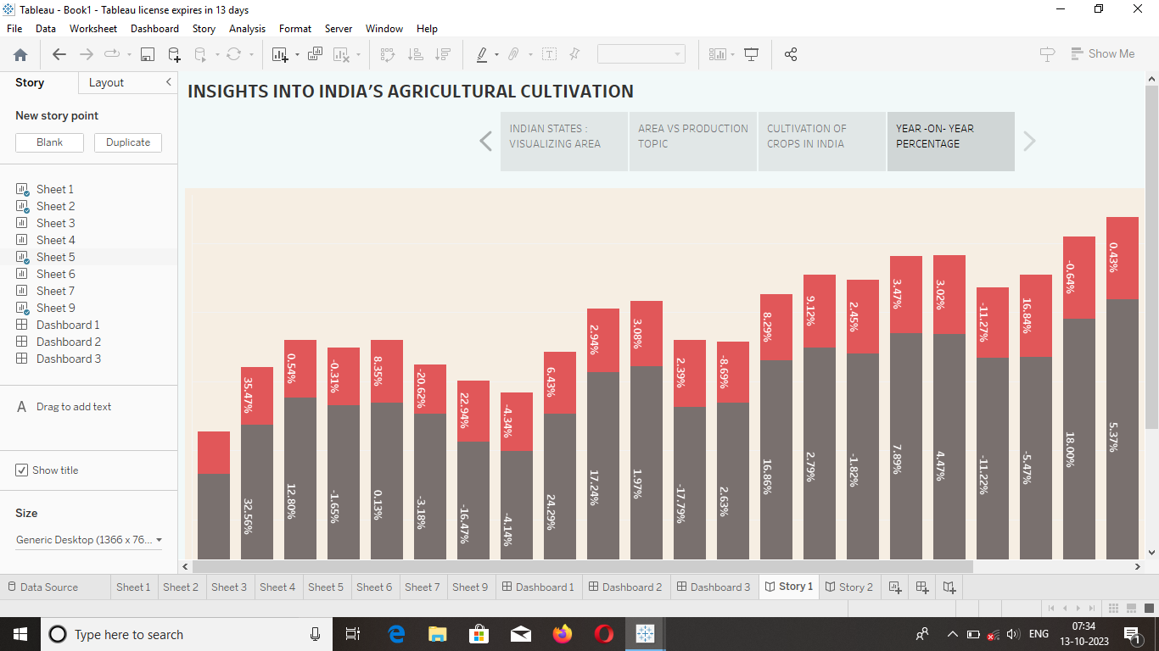

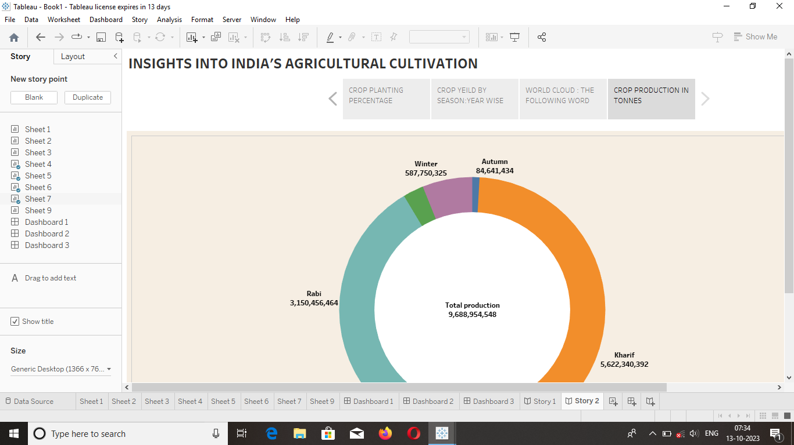

4. Advantages & disadvantages

Advantage of this project is finding a large area of agriculture land in India.

Disadvantage in this project is many agriculture land have small amount of production.

5. Applications

This project is applied in many agriculture related problems.

6.Conclusion

In this entire project we find the cultivation season of major crops.

7.Future scope

In the future season will change tremendously so the cultivation of crops is more challenging. This analysis will help for the future.